Digital-Nurture-4.0-JavaFSE-main

Hands-on in this document

Name: Thilak Ragav M

Superset ID : 6409405

Week Task : Week - 6

## **Objectives**

* Explain React components
* Identify the differences between components and JavaScript functions
* Identify the types of components
* Explain class component
* Explain function component
* Define component constructor
* Define render() function

In this hands-on lab, you will learn how to:

* Create a class component
* Create multiple components
* Render a component

## **Prerequisites**

The following is required to complete this hands-on lab:

* Node.js
* NPM
* Visual Studio Code

## **Notes**

Estimated time to complete this lab: **30 minutes.**

Create a react app for Student Management Portal named StudentApp and create a component named Home which will display the Message “Welcome to the Home page of Student Management Portal”. Create another component named About and display the Message “Welcome to the About page of the Student Management Portal”. Create a third component named Contact and display the Message “Welcome to the Contact page of the Student Management Portal”. Call all the three components.

1. Create a React project named “StudentApp” type the following command in terminal of Visual studio:



1. Create a new folder under Src folder with the name “Components”. Add a new file named “Home.js”
2. Type the following code in Home.js

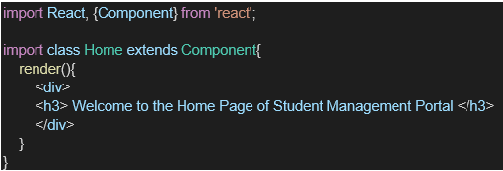

1. Under Src folder add another file named “About.js”
2. Repeat the same steps for Creating “About” and “Contact” component by adding a new file as ”About.js”, “Contact.js” under “Src” folder and edit the code as mentioned for “Home” Component.
3. Edit the App.js to invoke the Home, About and Contact component as follows:

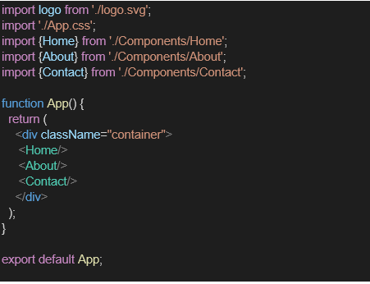

1. In command Prompt, navigate into StudentApp and execute the code by typing the following command:



1. Open browser and type “localhost:3000” in the address bar:

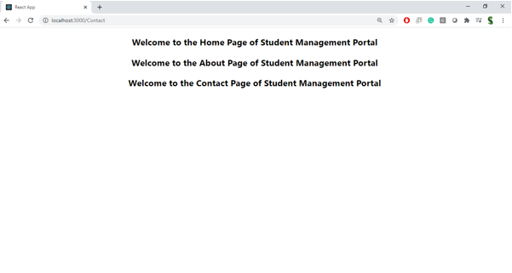

Index.js

import React from 'react';import ReactDOM from 'react-dom/client';import './index.css';import App from './App';import reportWebVitals from './reportWebVitals';const root = ReactDOM.createRoot(document.getElementById('root'));root.render( <React.StrictMode> <App /> </React.StrictMode>);// If you want to start measuring performance in your app, pass a function// to log results (for example: reportWebVitals(console.log))// or send to an analytics endpoint. Learn more: https://bit.ly/CRA-vitalsreportWebVitals();

App.js

import './App.css';import Home from './Components/Home';import About from './Components/About';import Contact from './Components/Contact';function App() { return ( <div className="App"> <Home /> <About /> <Contact /> </div> );}export default App;

Package.json:

{ "name": "studentapp", "version": "0.1.0", "private": true, "dependencies": { "@testing-library/dom": "^10.4.0", "@testing-library/jest-dom": "^6.6.3", "@testing-library/react": "^16.3.0", "@testing-library/user-event": "^13.5.0", "react": "^19.1.0", "react-dom": "^19.1.0", "react-scripts": "5.0.1", "web-vitals": "^2.1.4" }, "scripts": { "start": "react-scripts start", "build": "react-scripts build", "test": "react-scripts test", "eject": "react-scripts eject" }, "eslintConfig": { "extends": [ "react-app", "react-app/jest" ] }, "browserslist": { "production": [ ">0.2%", "not dead", "not op_mini all" ], "development": [ "last 1 chrome version", "last 1 firefox version", "last 1 safari version" ] }}

Output:

